Chapter 15, Solution 49.

(a) t*e^{αt}u(t) =
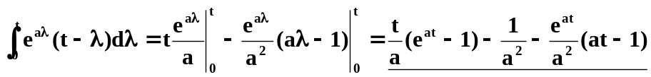u(t)

(b)
=[ 0.5cos(t)(t+0.5sin(2t)) – 0.5sin(t)(cos(t) – 1)]u(t).

